ALL ABOUT MRS. RAPPORT

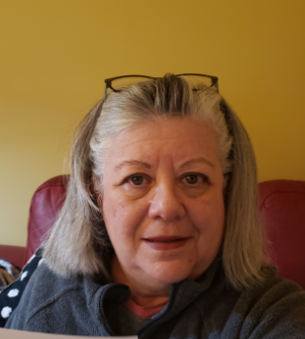



BA History & BS Education from the University of Cincinnati

MEd Admin from Ashland University

Elementary license from Capital University

Reading Endorsement from Notre Dame College

Favorite Things:

Traveling around the world!

Playing with my grandkids

Reading (of course!)

Quilting and sewing (I just learned how to knit!)

and these two!

A little about ME

I was born and raised in the Cleveland area. After graduation from Cleveland Heights High and the University of Cincinnati I married and moved through the state teaching in Columbus, Akron, and at Beth El Academy, Lawrence School and North Coast Academy. This was before I joined the staff at RH Jamison!

I have two children, one son in law, one daughter in law, two grandchildren, four sisters (& 4 brothers in law) and a ton of nieces and nephews.

